IT 490 CAPSTONE | WEEK 2 | CISCO PACKET TRACER
Basic Cisco Router Setup and Verification
Configuration of SEA-R01 from a new router state, with LAN and WAN addressing, SSH access, password protection, static routing, EIGRP, and documented verification

14  REQUIREMENTS MAPPED | 510  USABLE LAN HOSTS | SSH v2  ONLY VTY TRANSPORT | 19  EVIDENCE FIGURES

SUMMARY
Configuration of SEA-R01 from a new router state, with LAN and WAN addressing, SSH access, password protection, static routing, EIGRP, and documented verification. The tested management and routing paths worked. The assignment's static route overlaps the LAN subnet and remains a documented configuration limitation.

PROJECT SNAPSHOT
Author | Justin Martin
Course | IT490 Capstone, Green River College
Date | October 4, 2026
Environment | Cisco Packet Tracer, two Cisco 2911 routers (IOS 15.1), Cisco 2960 switch, one admin PC
Skills demonstrated | VLSM subnet sizing, IPv4 and IPv6 interface configuration, SSH hardening, Telnet restriction, password storage types, EIGRP, static routing, route-table analysis, verification testing

01 Executive Results
SEA-R01 was configured in Cisco Packet Tracer using a Cisco 2911 router. The LAN and WAN interfaces reached an up/up state, SSH access succeeded, Telnet access was rejected, and EIGRP exchanged the LAN route with WAN-R02. Both routers returned [OK] when their configurations were saved.
Area | Result | Evidence
LAN capacity | 192.168.16.1/23 provides 510 usable addresses | Figures 1.5 and 1.9
WAN interfaces | IPv4 and IPv6 link tests reached 100% success | Figures 1.6, 1.7 and 1.8
Remote access | SSH login and enable succeeded; Telnet was closed | Figures 1.10 and 1.11
EIGRP | Neighbor formed; WAN-R02 learned the LAN /23 | Figures 1.12 through 1.14
Static route | Required /24 installed; overlaps connected /23 | Figure 1.15
Final validation | PC reached LAN gateway and WAN peer with no loss | Figure 1.16
Persistence | Running configurations copied to startup configurations | Figures 1.17 and 1.18

02 Environment and Addressing
Device and interface | Address | Purpose
SEA-R01 Gi0/0 | 192.168.16.1/23 | LAN gateway
SEA-R01 Gi0/1 | 10.0.0.2/30 2001:db8:a0b:12f0::1/64 | WAN interface
WAN-R02 Gi0/0 | 10.0.0.1/30 2001:db8:a0b:12f0::2/64 | WAN test peer
Admin-PC Fa0 | 192.168.17.10/23 | SSH client and ping source
LAN-SW01 | 2960 switch with no management IP assigned | LAN connectivity

Admin-PC uses gateway 192.168.16.1 and DNS server 8.8.8.8. The PC connects to LAN-SW01 Fa0/1, the switch Gi0/1 connects to SEA-R01 Gi0/0, and SEA-R01 Gi0/1 connects to WAN-R02 Gi0/0.
The /30 WAN IPv4 subnet, /64 IPv6 prefix length, EIGRP autonomous system 100, local SSH account admin, domain abc.example, and supporting test devices are lab choices. The assignment specifies the primary router settings but does not supply these supporting values. The routers report IOS version 15.1.

LAN SUBNET CALCULATION
A /24 contains 256 total addresses and 254 usable host addresses, which is insufficient for 270 hosts. A /23 leaves 9 host bits: 2^9 − 2 = 510 usable host addresses. The mask is 255.255.254.0, the network is 192.168.16.0, the broadcast is 192.168.17.255, and the usable range is 192.168.16.1 through 192.168.17.254.
Prefix | Mask | Host bits | Usable hosts | Meets 270?
/24 | 255.255.255.0 | 8 | 254 | No
/23 | 255.255.254.0 | 9 | 510 | Yes

The test PC address 192.168.17.10 demonstrates use of the second half of the /23. It also falls outside the overlapping /24 static route. A successful ping from this address does not validate routing for the entire LAN.

03 Assignment Requirement Mapping
Item | Implemented setting | Verification
a | LAN 192.168.16.1 with mask 255.255.254.0; no shutdown | Gi0/0 up/up; 510 usable addresses
b | WAN 2001:db8:a0b:12f0::1/64; no shutdown | Gi0/1 up/up; IPv6 peer ping 5/5
c | hostname SEA-R01 | Final running configuration
d | ip name-server 8.8.8.8 | Final running configuration
e | transport input ssh on VTY 0 through 4 | Telnet connection closed without login
f | Local account, domain, RSA keys and SSH version 2 | Successful PC SSH session
g | enable secret It490Tmason! | Type 5 hash; enable access succeeded
h | service password-encryption; secret credentials | Type 7 line passwords and Type 5 secrets
i | no ip domain-lookup | Final running configuration
j | Console and VTY password iT490tMason* | Console login; VTY login local
k | ip route 192.168.16.0 255.255.255.0 10.0.0.1 | Static /24 installed; overlap discussed below
l | EIGRP 100 includes both directly connected IPv4 networks | Neighbor 10.0.0.1; learned LAN /23
m | Interface, SSH, route, neighbor and ping checks | Evidence section
n | show running-config | Final configuration appendices

04 Commands in Execution Order
These command sequences document the configuration workflow. Commands are entered at the router CLI unless a different device is named. The credentials are assignment supplied lab values.

1 ROUTER IDENTITY AND CONSOLE ACCESS
SEA-R01
enable
configure terminal
hostname SEA-R01
no ip domain-lookup
ip name-server 8.8.8.8
enable secret It490Tmason!
service password-encryption
line console 0
password iT490tMason*
login
logging synchronous
exit
end

The enable secret protects privileged EXEC access. Console login requires the assigned line password. logging synchronous prevents console status messages from disrupting typed commands.

2 SSH ACCESS AND TELNET RESTRICTION
SEA-R01
configure terminal
ip domain-name abc.example
username admin secret iT490tMason*
crypto key generate rsa
! modulus prompt: 2048
ip ssh version 2
line vty 0 4
password iT490tMason*
login local
transport input ssh
exit
end

At the RSA modulus prompt, enter 2048. This is an interactive response, not a separate IOS command. The key size was selected during setup; the supplied screenshots do not independently show the modulus.
login local authenticates SSH with the admin account. The assigned VTY line password is present, but local account authentication takes precedence. transport input ssh restricts these VTY lines to SSH (Cisco, 2026).

3 SEA-R01 LAN AND WAN INTERFACES
SEA-R01
configure terminal
ipv6 unicast-routing
interface GigabitEthernet0/0
description LAN connection to LAN-SW01
ip address 192.168.16.1 255.255.254.0
no shutdown
exit
interface GigabitEthernet0/1
description WAN connection to WAN-R02
ip address 10.0.0.2 255.255.255.252
ipv6 address 2001:db8:a0b:12f0::1/64
no shutdown
exit
end

4 WAN-R02 SUPPORTING PEER
WAN-R02
enable
configure terminal
hostname WAN-R02
no ip domain-lookup
ipv6 unicast-routing
interface GigabitEthernet0/0
description WAN connection to SEA-R01
ip address 10.0.0.1 255.255.255.252
ipv6 address 2001:db8:a0b:12f0::2/64
no shutdown
exit
end

5 ADMIN PC ADDRESSING
In Desktop → IP Configuration, select Static. Enter IPv4 address 192.168.17.10, subnet mask 255.255.254.0, default gateway 192.168.16.1, and DNS server 8.8.8.8. No global IPv6 address was assigned to the PC.

6 EIGRP ON SEA-R01
SEA-R01
configure terminal
router eigrp 100
no auto-summary
network 192.168.16.0 0.0.1.255
network 10.0.0.0 0.0.0.3
passive-interface GigabitEthernet0/0
end

The network statements select the LAN and WAN interfaces for IPv4 EIGRP. The LAN is passive to prevent neighbor formation toward the PC while retaining its network advertisement (Cisco, 2011).

7 EIGRP ON WAN-R02
WAN-R02
configure terminal
router eigrp 100
no auto-summary
network 10.0.0.0 0.0.0.3
end

8 REQUIRED STATIC ROUTE ON SEA-R01
SEA-R01
configure terminal
ip route 192.168.16.0 255.255.255.0 10.0.0.1
end

IOS static routes specify a destination prefix and next hop. The assignment's phrase "from 192.168.16.0/24 to 10.0.0.1" is implemented as a destination route for 192.168.16.0/24 through 10.0.0.1. This interpretation creates the overlap described in the technical analysis.

9 VERIFICATION AND SAVING
Device | Verification commands
SEA-R01 | show ip interface brief, show ipv6 interface brief, show ip ssh, show ip eigrp neighbors, show ip protocols, show ip route, ping 10.0.0.1, ping 2001:db8:a0b:12f0::2
WAN-R02 | show ip route, ping 192.168.17.10
Admin-PC | ssh -l admin 192.168.16.1, authenticate with iT490tMason*, enter enable and authenticate with It490Tmason!, then exit. Test telnet 192.168.16.1, ping 192.168.16.1, and ping 10.0.0.1.

BOTH ROUTERS
copy running-config startup-config
show running-config

Run the save command on both routers and press Enter at the destination filename prompt. The [OK] outputs confirm successful writes. Save the Packet Tracer project separately to retain the topology.

05 Technical Analysis and Reflection

STATIC ROUTE OVERLAP
SEA-R01 contains a connected 192.168.16.0/23 route and a static 192.168.16.0/24 route through WAN-R02. The routing table visibly contains both. The /24 is more specific, so traffic for other 192.168.16.x hosts matches the static route rather than the connected /23. The router's own 192.168.16.1 address retains a local /32 route (Cisco, 2024a).
WAN-R02 learned 192.168.16.0/23 through SEA-R01. Based on these installed routes, traffic to another 192.168.16.x LAN host would be forwarded toward WAN-R02 and then back toward SEA-R01, creating a routing loop. This consequence is inferred from the route tables; no affected host or loop test was added. Tests with 192.168.17.10 succeed because that address does not match the static /24.
The literal assignment route remains in the saved configuration for the exercise. Before using this design operationally, clarify the intended remote destination and remove or replace the overlapping route. A default route through 10.0.0.1 would be appropriate only if WAN-R02 actually provides an upstream path; that role was not established in this lab. Retest hosts in both halves of the /23 after correcting the requirement.

PASSWORD PROTECTION AND MANAGEMENT ACCESS
The final SEA-R01 configuration stores the enable secret and admin secret as Type 5 hashes. Console and VTY line passwords appear as Type 7 values after service password-encryption. Type 7 is reversible obfuscation, not strong password protection; Type 5 uses an older MD5 based hash. The assignment's password storage requirement is demonstrated, but these mechanisms should not be presented as modern production security (Cisco, 2024b). Newer IOS releases support Type 8 and Type 9 secrets through the algorithm-type option, which the IOS 15.1 image in this lab does not offer.
SSH version 2 was confirmed, and an actual SSH session reached privileged EXEC mode. The Telnet attempt briefly displayed "Open" and then closed without providing a login. Together with transport input ssh, this supports rejection of Telnet management access. WAN-R02 served only as a test peer; the assignment's management hardening was applied to SEA-R01.

VALIDATION LIMITS
The initial IPv4 WAN ping returned 4/5 replies; the repeat returned 5/5. Address resolution could explain the first loss, but no capture confirmed it. IPv6 WAN connectivity returned 5/5. DNS resolution, Internet connectivity, and persistence after reload were not tested.
Items d and i also interact. With no ip domain-lookup in place, the router does not query the configured name server, so 8.8.8.8 is stored in the configuration but not used by SEA-R01 itself. If router-side name resolution were needed later, transport preferred none on the console and VTY lines would still stop typos from being treated as Telnet hostnames while leaving domain lookup enabled.
show ip protocols confirmed disabled automatic summarization. The no auto-summary command does not appear in the running configurations because automatic summarization is already disabled by default in IOS 15, so IOS does not display it. IPv6 was tested only on the directly connected WAN; IPv6 EIGRP was not configured.

REFLECTION
This exercise reinforced that entering a command successfully does not guarantee a sound routing design. I had to calculate the LAN mask from the host requirement, verify access with an actual SSH session, and compare the static route with the connected network. The overlap was the most useful lesson because successful pings from one address range could hide a problem elsewhere in the same LAN.

06 Evidence
Evidence of Initial Configuration
Figure 1.1 — Initial topology with router links still down before interface configuration.
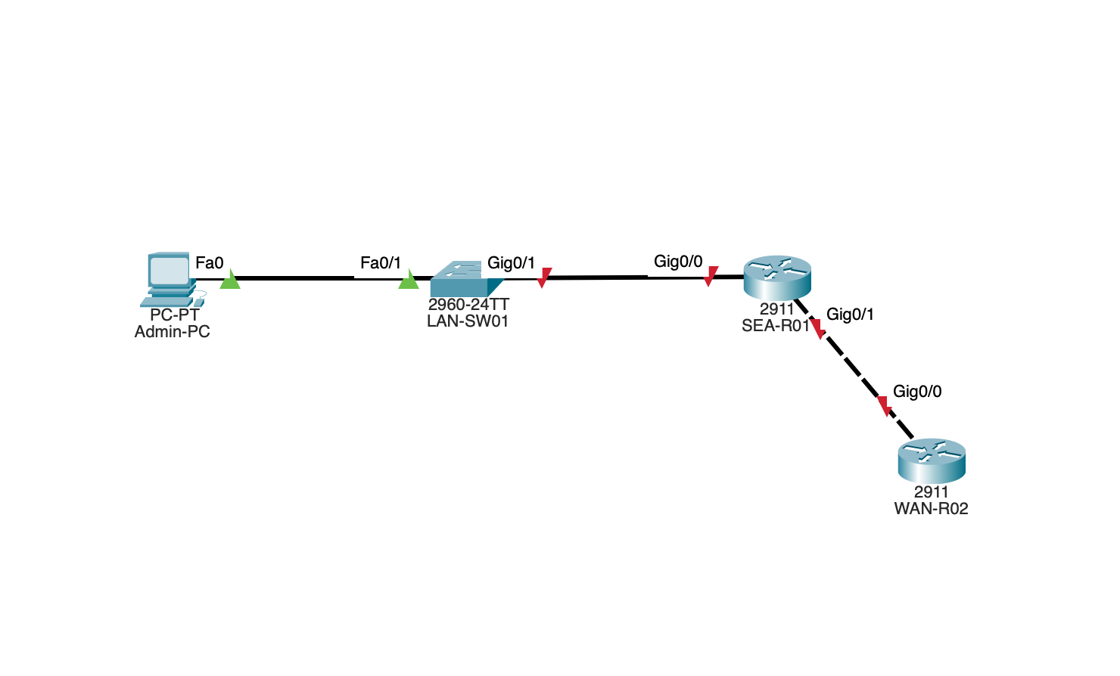
Figure 1.2 — Early running configuration shows the hostname, enable secret, password service, and DNS settings.
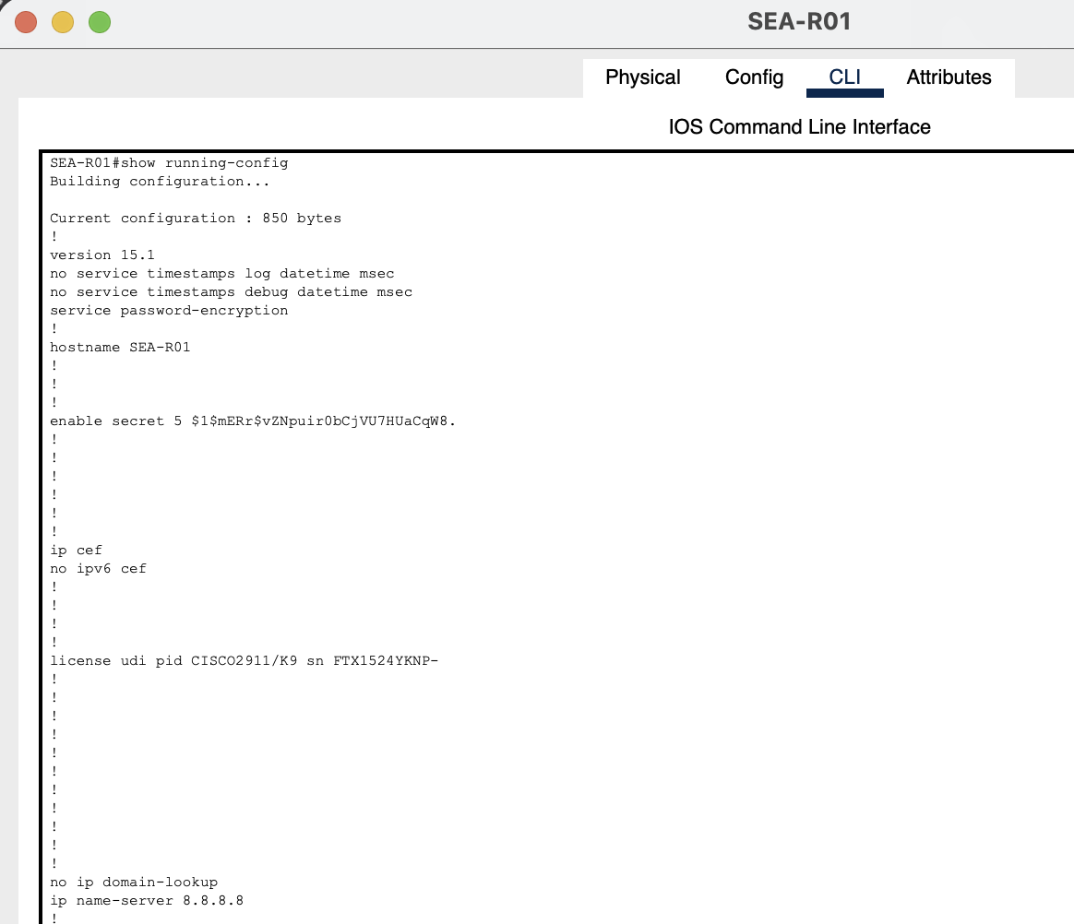
Evidence of SSH Configuration
Figure 1.3 — show ip ssh confirms SSH version 2.0.
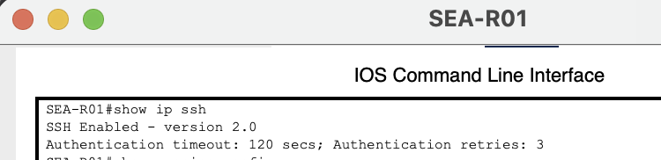
Figure 1.4 — Console and VTY configuration shows Type 7 passwords, local SSH authentication, and SSH only transport.
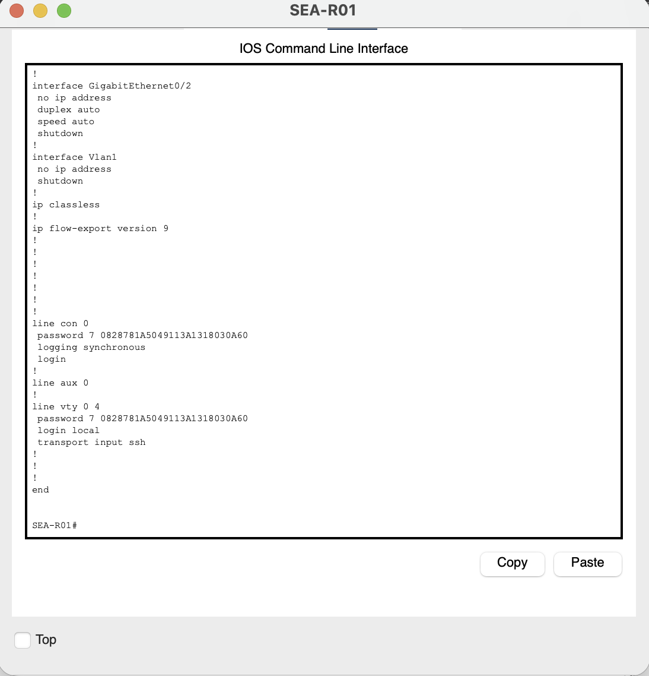
Evidence of Interface Status
Figure 1.5 — IPv4 interface summary shows both configured router interfaces up/up.
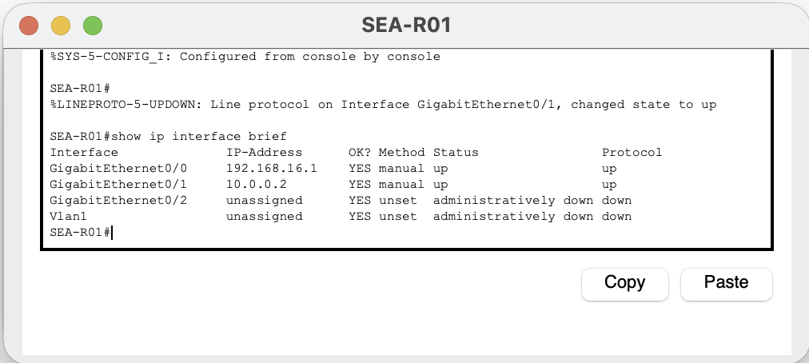
Figure 1.6 — IPv6 interface summary shows the required WAN address on Gi0/1 in an up/up state.
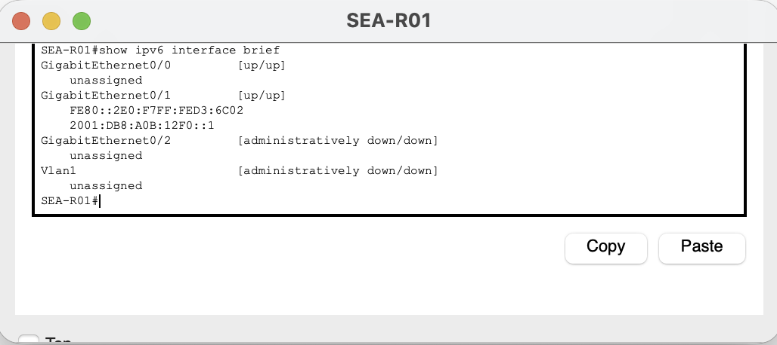
Evidence of WAN Connectivity
Figure 1.7 — Initial WAN tests show IPv4 success of 4/5 and IPv6 success of 5/5.
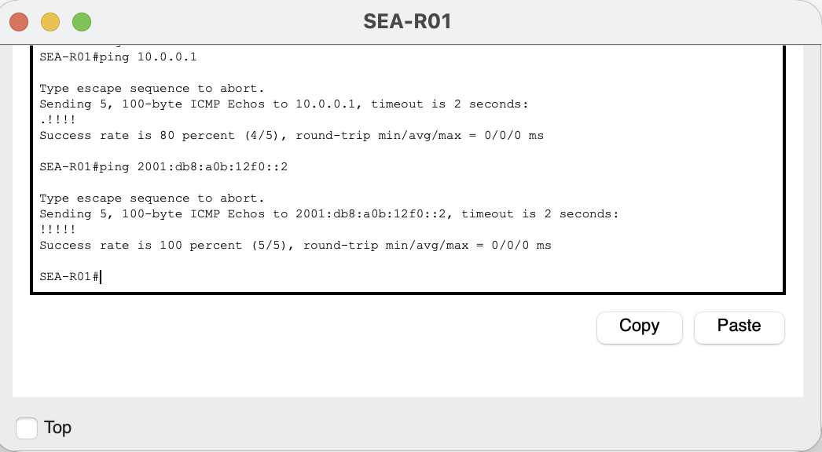
Figure 1.8 — Repeated IPv4 WAN ping succeeds with 5/5 replies.
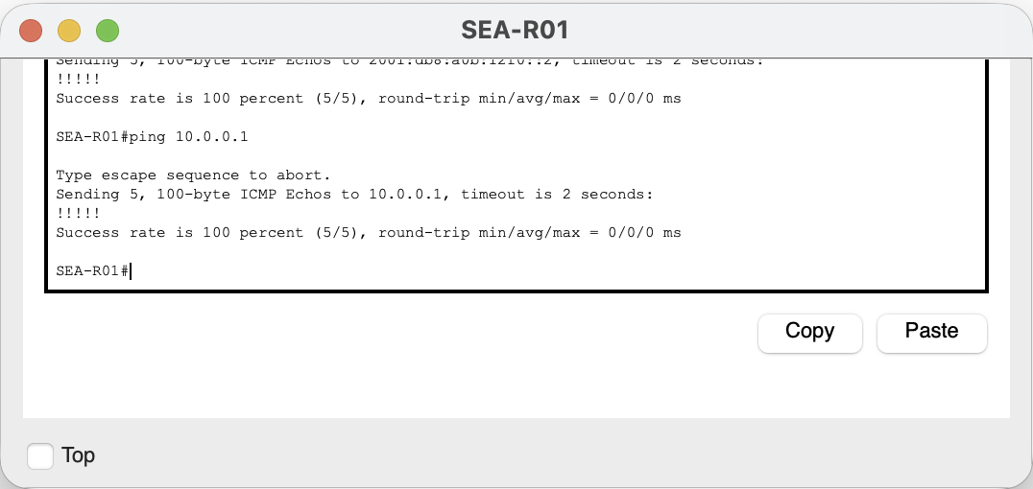
Evidence of Admin PC Addressing
Figure 1.9 — Admin PC uses 192.168.17.10 with the /23 mask, LAN gateway, and assigned DNS server.
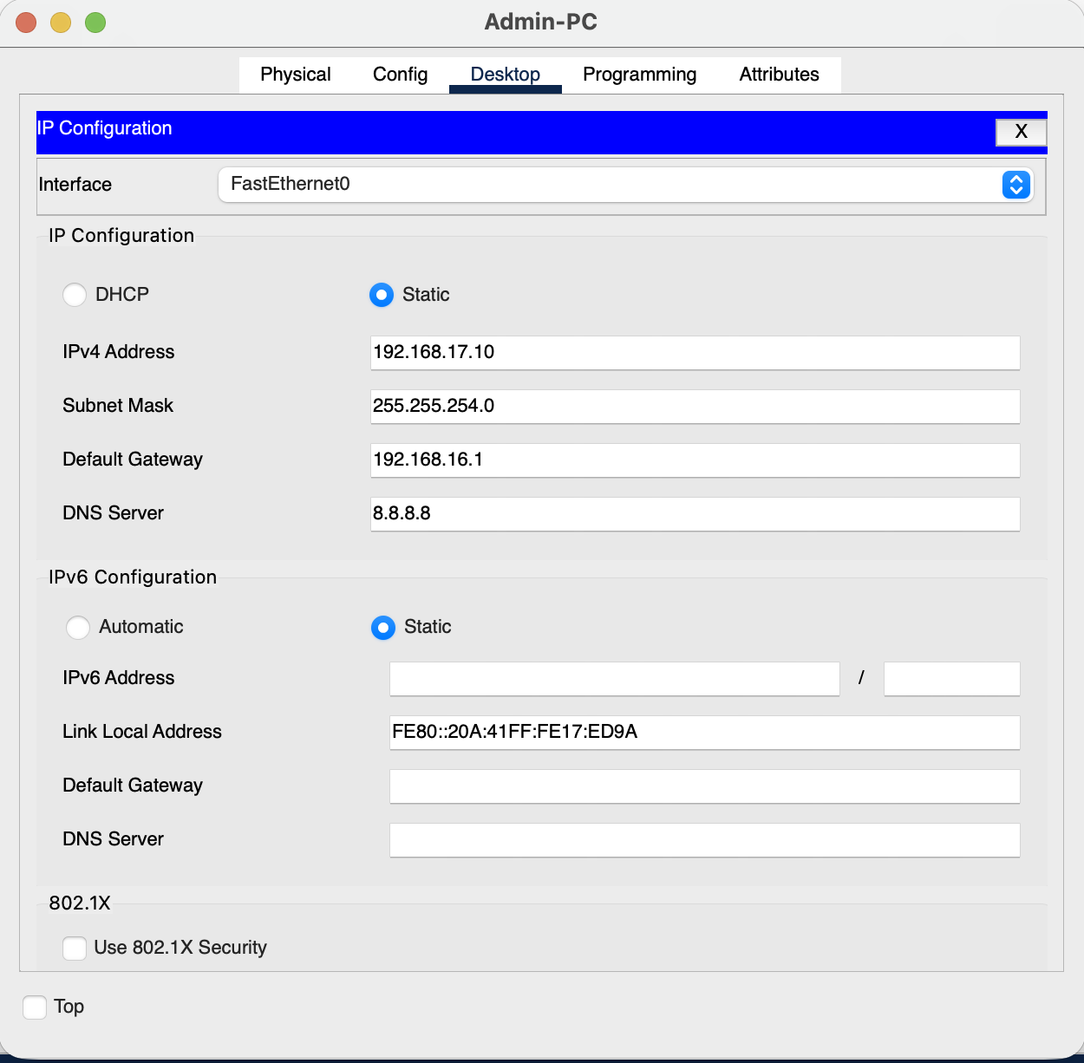
Evidence of Remote Access Tests
Figure 1.10 — The PC authenticates over SSH and reaches the SEA-R01 privileged EXEC prompt.
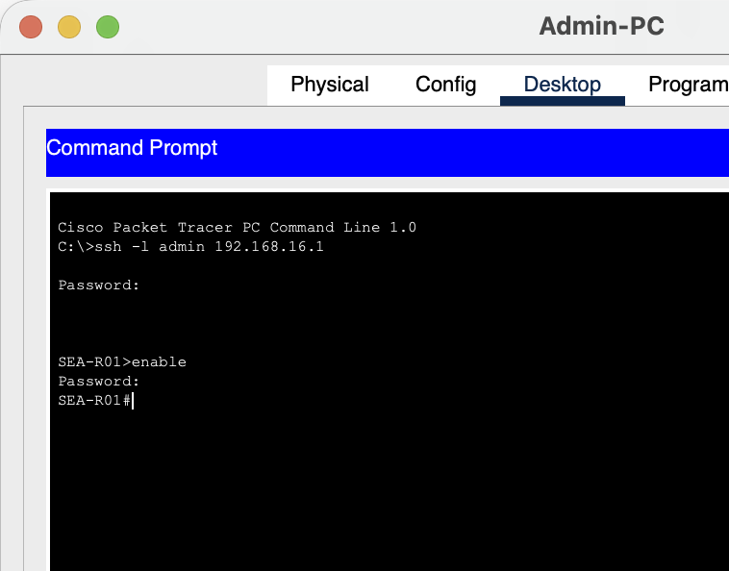
Figure 1.11 — The Telnet attempt is closed by the router without providing a login session.
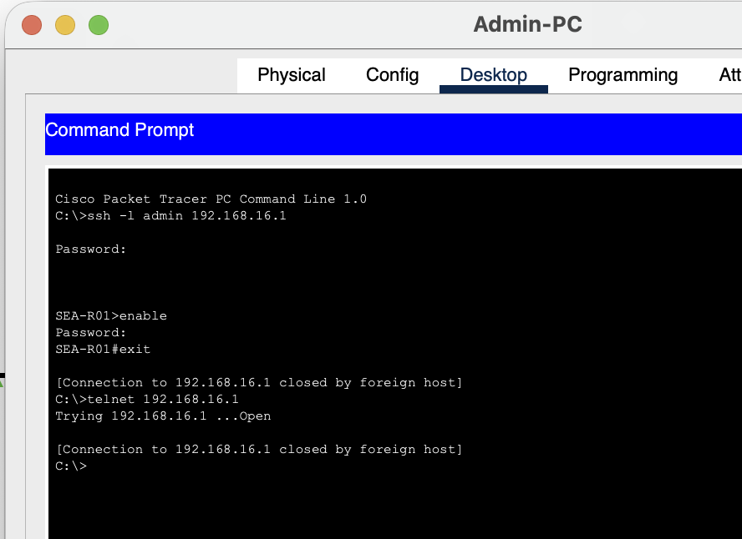
Evidence of EIGRP Operation
Figure 1.12 — EIGRP neighbor 10.0.0.1 is established; both networks are included and the LAN interface is passive.
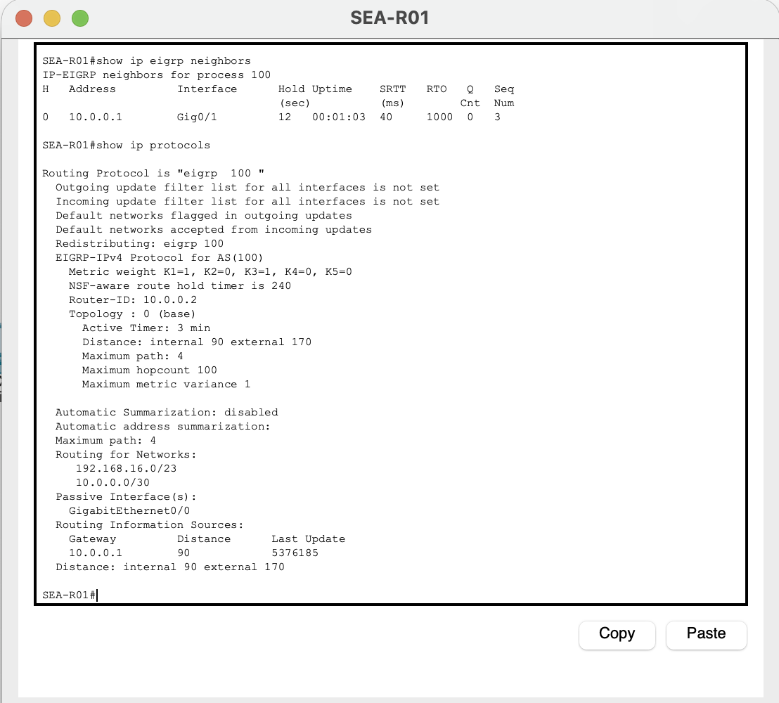
Evidence of Learned Route and Return Traffic
Figure 1.13 — WAN-R02 learns 192.168.16.0/23 through EIGRP via 10.0.0.2.
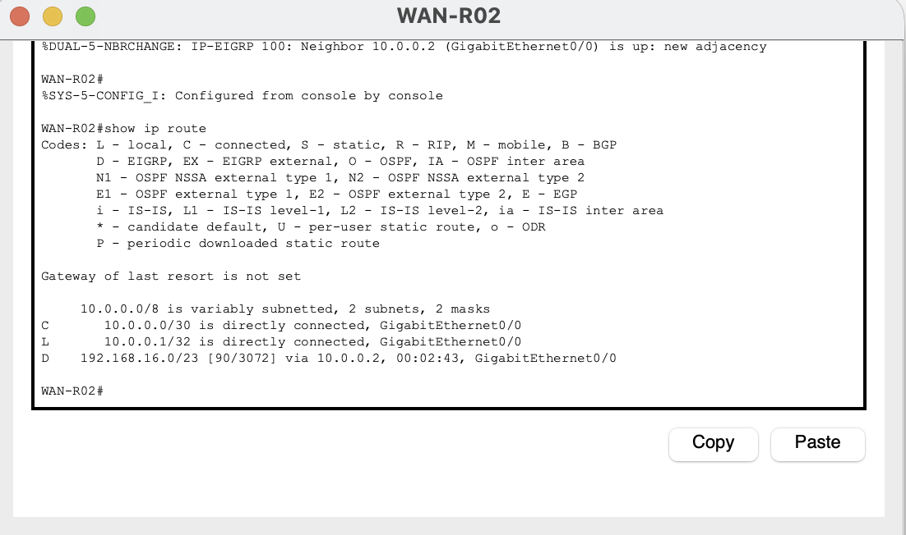
Figure 1.14 — WAN-R02 reaches the LAN PC using the learned route with 5/5 ping replies.
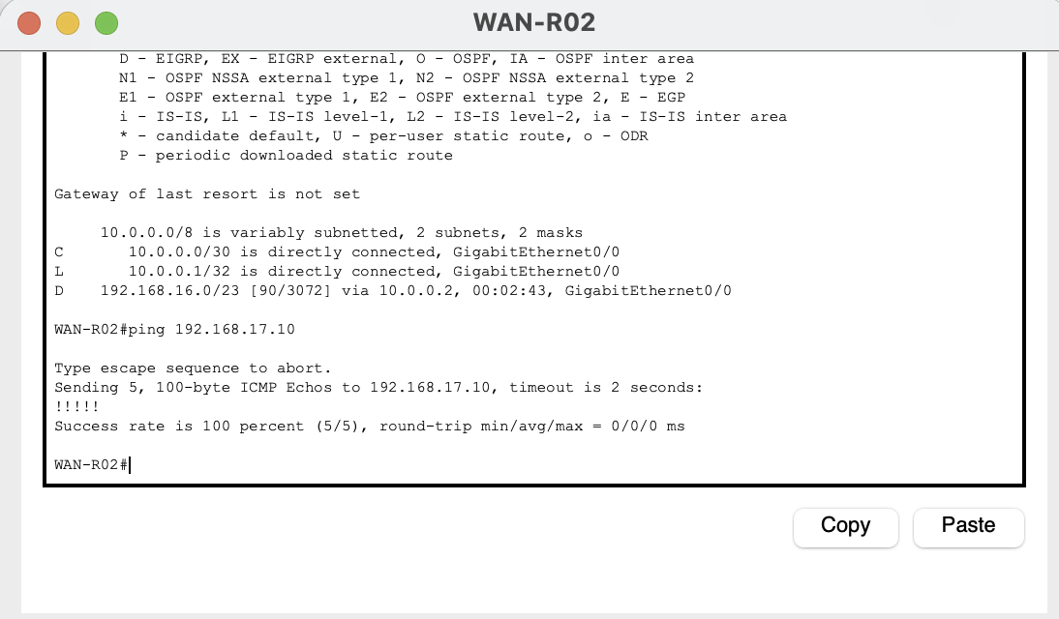
Evidence of Required Static Route
The installed /24 satisfies the literal command interpretation. Its overlap with the connected /23 is documented in the technical analysis.
Figure 1.15 — SEA-R01 installs the assignment static /24 alongside the overlapping connected /23.
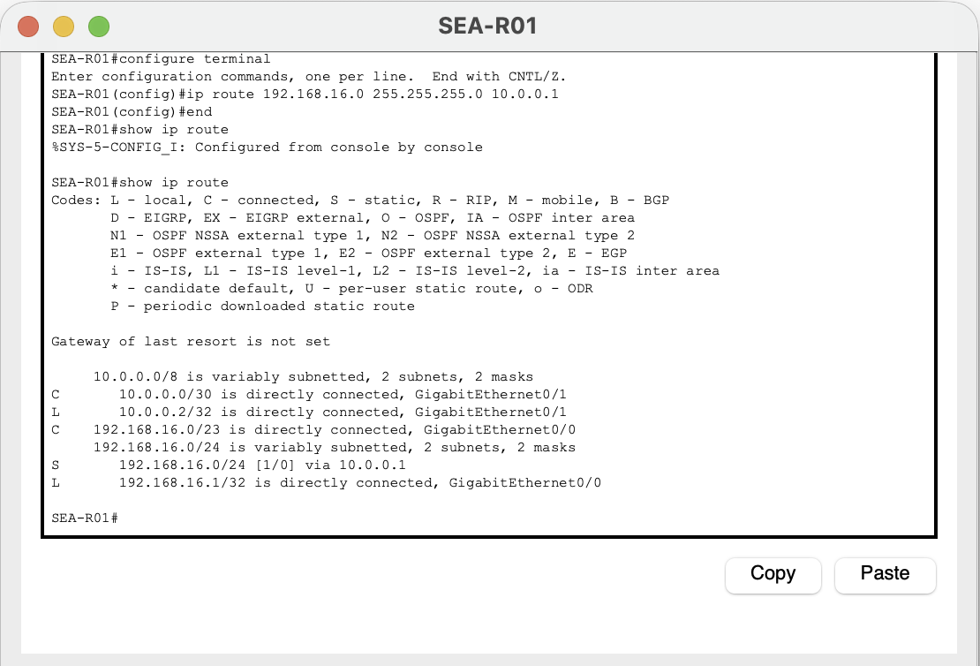
Evidence of Final PC Connectivity
Figure 1.16 — Admin PC reaches the LAN gateway and WAN peer with 4/4 replies and 0% loss for each.
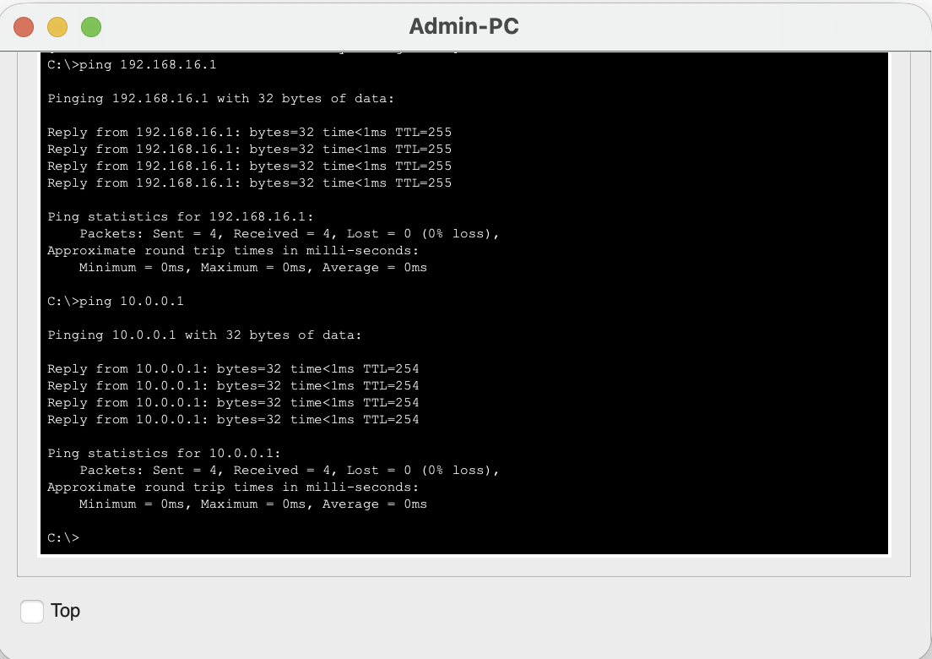
Evidence of Configuration Saving
Figure 1.17 — SEA-R01 saves its running configuration to startup configuration with an OK confirmation.
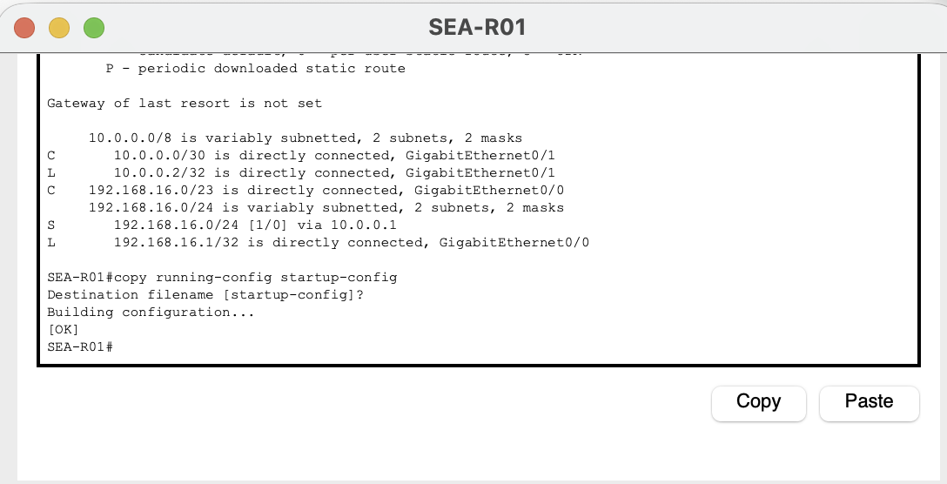
Figure 1.18 — WAN-R02 saves its running configuration to startup configuration with an OK confirmation.
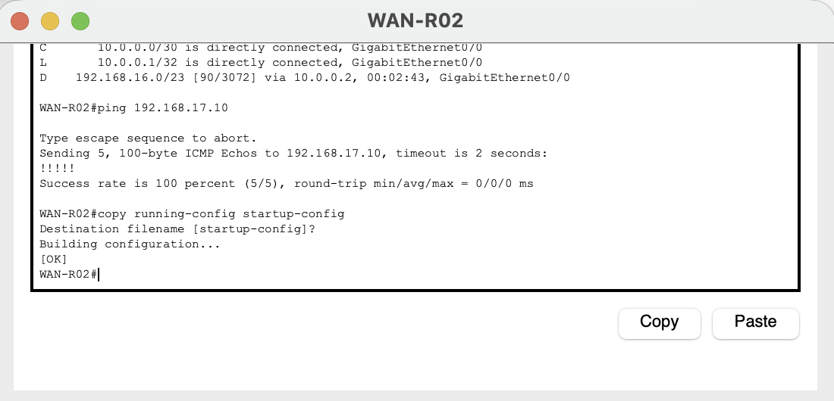
Evidence of Final Topology
Figure 1.19 — Final topology shows green link indicators between all four devices.
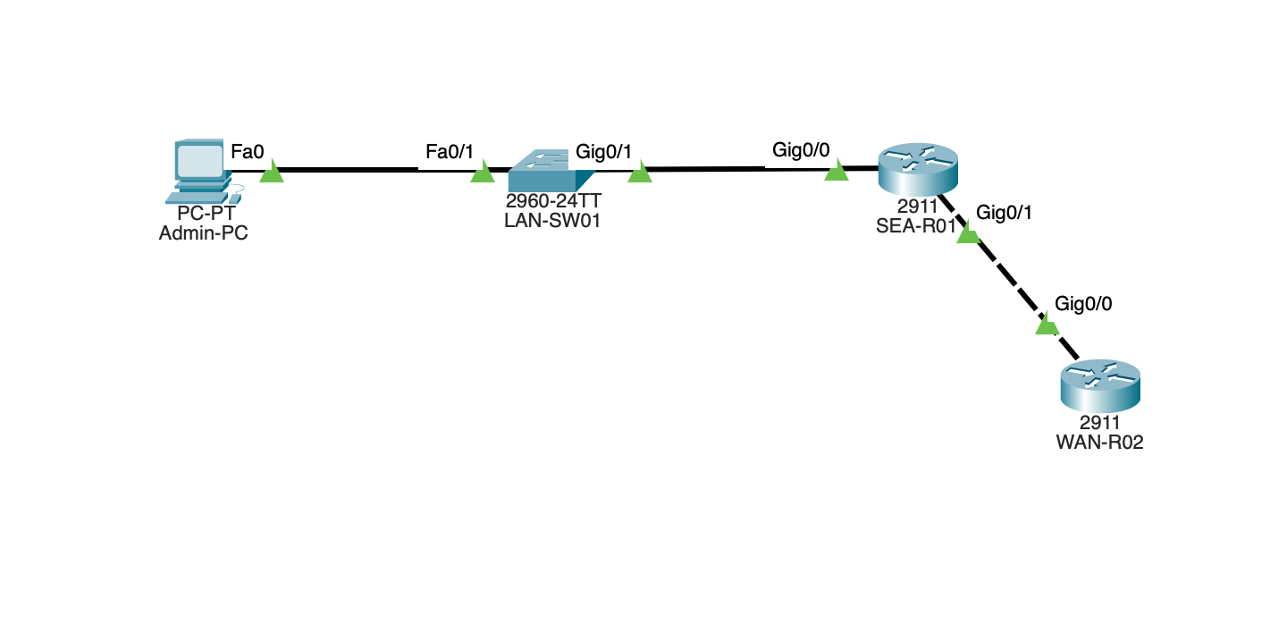

Final SEA-R01 Running Configuration
Captured after configuration and save verification. The output below preserves the supplied running configuration, including IOS separator lines.
SEA-R01#show running-config  Building configuration...  Current configuration : 1344 bytes  !  version 15.1  no service timestamps log datetime msec  no service timestamps debug datetime msec  service password-encryption  !  hostname SEA-R01  !  !  !  enable secret 5 $1$mERr$vZNpuir0bCjVU7HUaCqW8.  !  !  !  !  !  !  ip cef  ipv6 unicast-routing  !  no ipv6 cef  !  !  !  username admin secret 5 $1$mERr$mFGr.HZHSHlB0ulUXLjNi1  !  !  license udi pid CISCO2911/K9 sn FTX1524YKNP-  !  !  !  !  !  !  !  !  !  !  !  ip ssh version 2  no ip domain-lookup  ip domain-name abc.example  ip name-server 8.8.8.8  !  !  spanning-tree mode pvst  !  !  !  !  !  ! | interface GigabitEthernet0/0  description LAN connection to LAN-SW01  ip address 192.168.16.1 255.255.254.0  duplex auto  speed auto  !  interface GigabitEthernet0/1  description WAN connection to WAN-R02  ip address 10.0.0.2 255.255.255.252  duplex auto  speed auto  ipv6 address 2001:DB8:A0B:12F0::1/64  !  interface GigabitEthernet0/2  no ip address  duplex auto  speed auto  shutdown  !  interface Vlan1  no ip address  shutdown  !  router eigrp 100  passive-interface GigabitEthernet0/0  network 192.168.16.0 0.0.1.255  network 10.0.0.0 0.0.0.3  !  ip classless  ip route 192.168.16.0 255.255.255.0 10.0.0.1  !  ip flow-export version 9  !  !  !  !  !  !  !  line con 0  password 7 0828781A5049113A1318030A60  logging synchronous  login  !  line aux 0  !  line vty 0 4  password 7 0828781A5049113A1318030A60  login local  transport input ssh  !  !  !  end

Final WAN-R02 Running Configuration
Captured after configuration and save verification. The output below preserves the supplied running configuration, including IOS separator lines.
WAN-R02#show running-config  Building configuration...  Current configuration : 871 bytes  !  version 15.1  no service timestamps log datetime msec  no service timestamps debug datetime msec  no service password-encryption  !  hostname WAN-R02  !  !  !  !  !  !  !  !  ip cef  ipv6 unicast-routing  !  no ipv6 cef  !  !  !  !  license udi pid CISCO2911/K9 sn FTX1524AZIU-  !  !  !  !  !  !  !  !  !  !  !  no ip domain-lookup  !  !  spanning-tree mode pvst  !  !  !  !  ! | !  interface GigabitEthernet0/0  description WAN connection to SEA-R01  ip address 10.0.0.1 255.255.255.252  duplex auto  speed auto  ipv6 address 2001:DB8:A0B:12F0::2/64  !  interface GigabitEthernet0/1  no ip address  duplex auto  speed auto  shutdown  !  interface GigabitEthernet0/2  no ip address  duplex auto  speed auto  shutdown  !  interface Vlan1  no ip address  shutdown  !  router eigrp 100  network 10.0.0.0 0.0.0.3  !  ip classless  !  ip flow-export version 9  !  !  !  !  !  !  !  line con 0  !  line aux 0  !  line vty 0 4  login  !  !  !  end

References
Cisco. (2011, April 21). Configuring EIGRP. Cisco IOS 15.0S. https://www.cisco.com/en/US/docs/ios-xml/ios/iproute_eigrp/configuration/15-0s/Configuring_EIGRP.html
Cisco. (2024a, January 17). Configure route selection for routers. https://www.cisco.com/c/en/us/support/docs/ip/enhanced-interior-gateway-routing-protocol-eigrp/8651-21.html
Cisco. (2024b, July 22). Understand Cisco IOS password encryption. https://www.cisco.com/c/en/us/support/docs/security-vpn/remote-authentication-dial-user-service-radius/107614-64.html
Cisco. (2026, July 30). Configure SSH on routers. https://www.cisco.com/c/en/us/support/docs/security-vpn/secure-shell-ssh/4145-ssh.html
Lab evidence consists of the Packet Tracer screenshots and final router configurations captured on October 4, 2026.

